Hey Everyone,

I have started off with a new GTA series that i intend on doing to further my skills on Game Developement and coding in Unity.

I have just begun so i'll keep updating but here's my progress report till now.

If you do copy the design and code, please do give creds :)

Here's a peek into what I have been designing and coding for the last 2-3 days haha

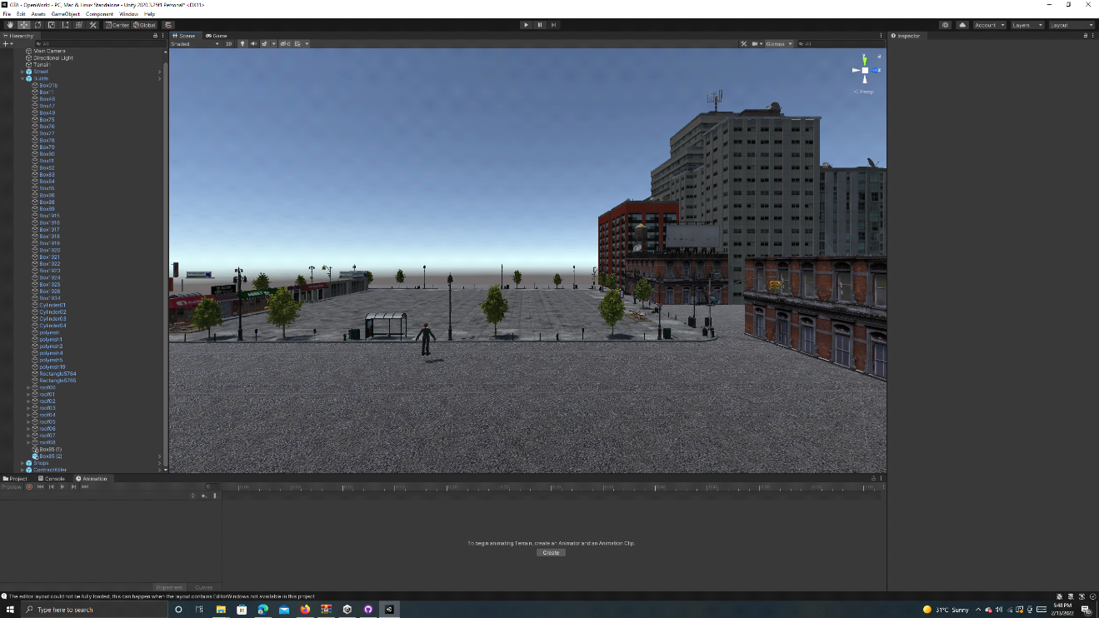

So thats my Real World city scene above that I have just started on

